Years 5 Maths Conference Checklist
Place Value | Subtraction |  |  | Multiplication | Division
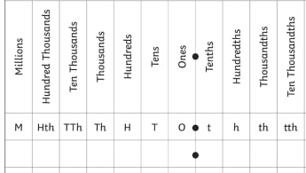 | Column Subtraction  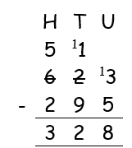  623 – 295 = |  |  | Short Multiplication  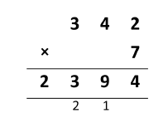  342 x 7 =  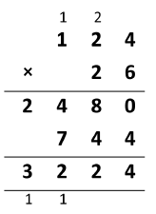  Long Multiplication  124 x 26 = | Short Division  81 ÷ 3 =  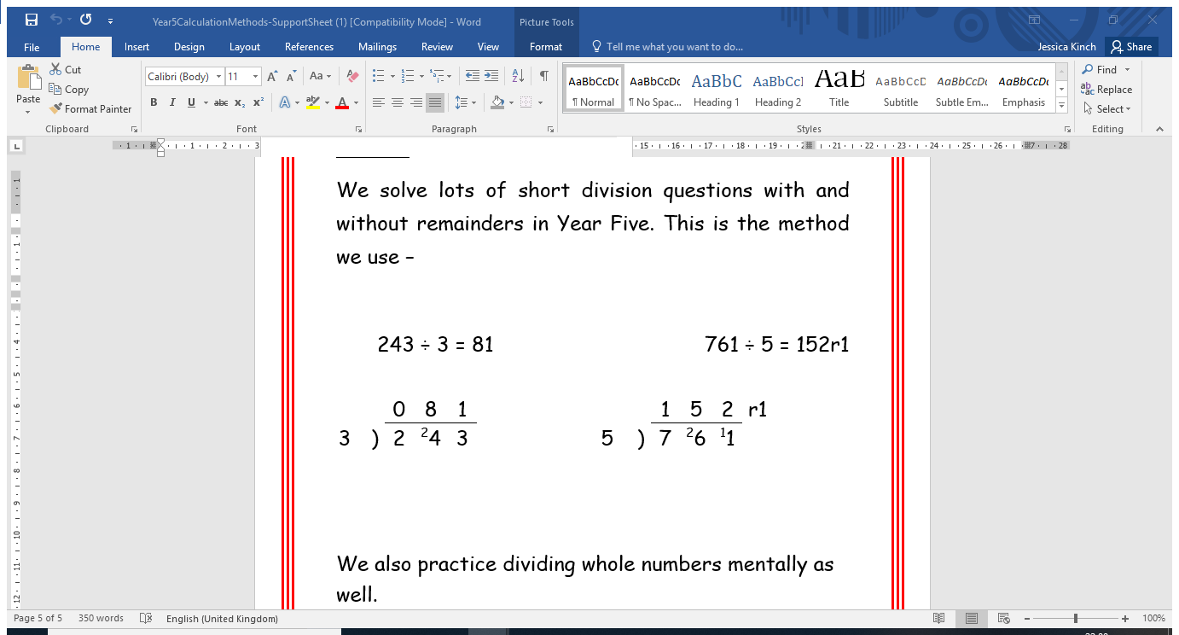  152 ÷ 5 =
 | Addition
Column Addition

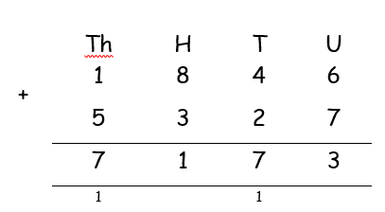
1846 + 5327 =
Negative Numbers
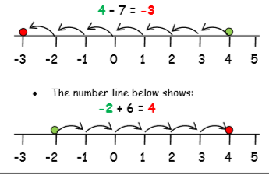
 |  |  |  |  | Multiplying and Dividing by 10, 100 and 1000
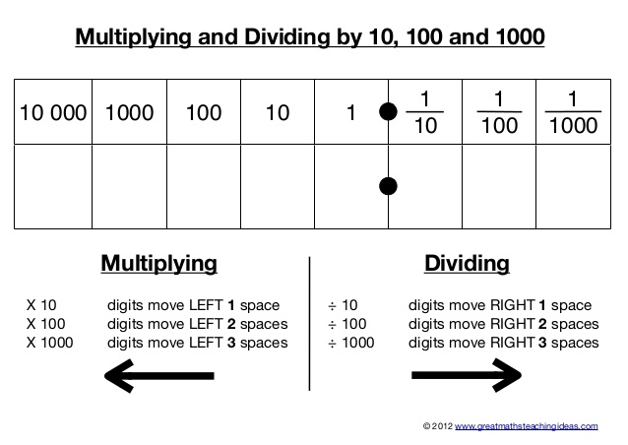

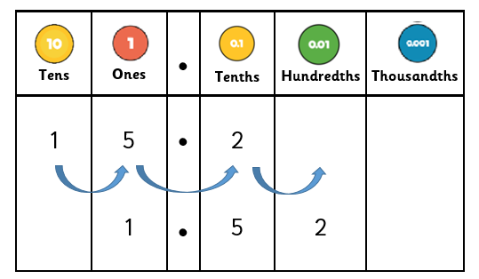
 |  |  |  | Fractions of Amounts
Adding Fractions | Subtracting Fractions |  |  | 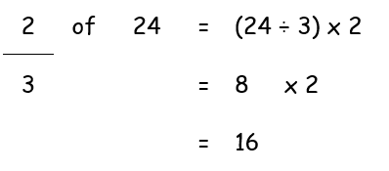
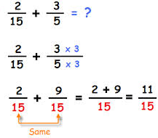 | 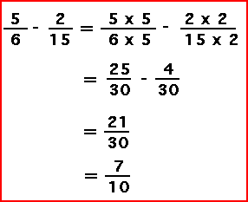
 |  |  |  | Multiplying Fractions
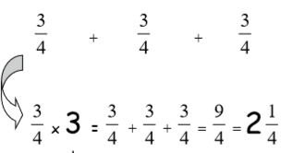
¾ x 3 =
Measurement conversions |  |  | Angles |  |  | Fractions, Decimals and Percentages
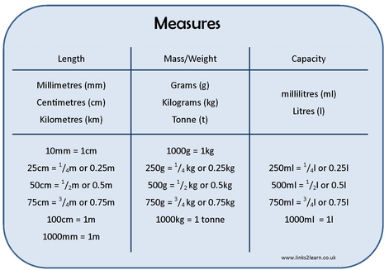
  Full turn | 360º
  Half turn | 180 º
  Right angle | 90 º
  Acute angle | <90º
  Obtuse angle | >90 º
  Reflex angle | >180 º
  Angles on a straight line | 180 º
  Angles inside a triangle | 180 º
  Angles inside a quadrilateral | 360 º
  ^{1/}₁₀₀ | 0.01 | 1% | ÷ 100
  ^{1/}₂₀ | 0.05 | 5% | ÷ 20
  ¹/₁₀ | 0.1 | 10% | ÷ 10
  ¹/₅ | 0.2 | 20% | ÷ 5
  ¼ | 0.25 | 25% | ÷ 4
  ½ | 0.5 | 50% | ÷ 2
  ¾ | 0.75 | 75% | ÷ 4, x3
  1 | 1 | 100% | ÷ 1
 |  |  | Key Vocabulary
Term | Defintion | Example
Factor | A number that divised exactly into another number | Factors of 12 =  1, 2, 3, 4, 6, 12
Common factor | Factors of two numbers that are the same | Common factors of 8 and 12 = 1, 2, 4
Prime number | A number with only 2 factors: 1 and itself | 2, 3, 5, 7, 11, 13, 17, 19 …
Composite number | A number with more than two factors | 12  (it has 6 factors)
Prime factor | A factor that is prime | Prime factors of 12 =  2, 3
Multiple | A number in another number’s times tables | Multiples of 9 =  9, 18, 27, 36…
Common multiple | Multiples of two number that are the same | Common multiples of 4 and 6 = 12, 24 …
Square numbers | The result when a number has been multiplied by itself | 5² = 5 x 5 = 25  7² = 7 x 7 = 49
Cube numbers | The result when a number has been multiplied by iteself 3 times | 2³ = 2 x 2 x 2 = 8  3³ = 3 x 3 x 3 = 27

Rounding |  | Roman Numerals
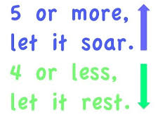  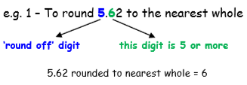  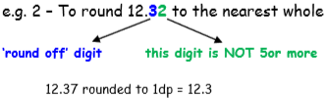 |  | 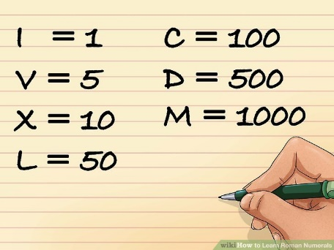  IV = 4  IX = 9  XL = 40  2006 = MMVI

