Privacy notice for parents and carers – use of your child’s
personal data

St Michaels Primary School
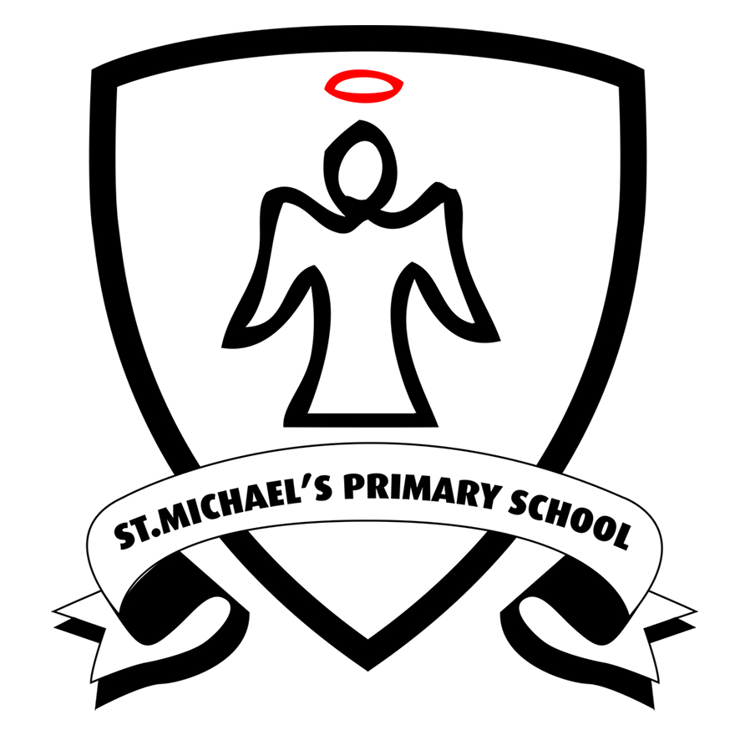

Contents
1. Introduction 3
2. The personal data we hold 3
3. Why we use this data 4
4. Our lawful basis for using this data 5
5. Collecting this data 6
6. How we store this data 6
7. Who we share data with 7
8. Your rights 9
9. Complaints 10
10. Contact us 10

1. Introduction
Under UK data protection law, individuals have a right to be informed about how our school uses any personal data that we hold about them. We comply with this right by providing ‘privacy notices’ (sometimes called ‘fair processing notices’) to individuals where we are processing their personal data.
This privacy notice explains how we collect, store and use personal data about pupils at our school.
This privacy notice applies while we believe your child is not capable of understanding and exercising their own data protection rights.
We, St Michael’s Primary School, Dee Road, Reading, RG30 4AS 0118 9015550 are the ‘data controller’ for the purposes of UK data protection law.

2. The personal data we hold
We hold personal data about pupils at our school to support teaching and learning, to provide pastoral care and to assess how the school is performing.
Personal data that we may collect, use, store and share (when appropriate) about your child includes, but is not restricted to:
- Contact details, contact preferences, date of birth, identification documents
- Results of internal assessments and externally set tests
- Pupil and curricular records
- Exclusion information
- Attendance information
- Safeguarding information
- Details of any support received, including care packages, plans and support providers
- Information about your child’s use of our information and communications systems, equipment and facilities (e.g. school computers)
We may also collect, use, store and share (when appropriate) information about your child that falls into ‘special categories’ of more sensitive personal data. This includes, but is not restricted to:
- Information about any medical conditions we need to be aware of, including physical and mental health
- Photographs and CCTV images captured in school
- Information about characteristics, such as ethnic background or special educational needs (SEN)
We may also hold data about your child that we have received from other organisations, including other schools and local authorities.

3. Why we use this data
We collect and use the data listed above to:
- Support pupil learning & SEN needs
- Monitor and report on pupil progress & SEN needs
- Provide appropriate pastoral care
- Protect pupil welfare
- Assess the quality of our services
- Assess data
- Comply with the law regarding data sharing
- Make sure our information and communication systems, equipment and facilities (e.g. school computers) are used appropriately, legally and safely
We will only use your child’s personal information for the purposes for which we have collected it, unless we reasonably consider that we need to use it for any other reason and that reason is incompatible with the original purpose. If we need to use your child’s personal information for an unrelated purpose, we will notify you and explain the legal basis that allows us to do so.
Please note that we may process your child’s personal information without your knowledge or consent in compliance with the above rules where this is required or permitted by law.
3.1 Use of your child’s personal data in automated decision-making and profiling
We do not currently process any pupils’ personal data through automated decision-making or profiling. If this changes in the future, we will amend any relevant privacy notices to explain the processing to you, including your right to object to it.
3.2 Use of your child’s personal data for filtering and monitoring purposes
While your child is in our school, we may monitor their use of our information and communication systems, equipment and facilities (e.g. school computers). We do this so we can:
- Comply with health and safety, and other legal obligations
- Comply with our policies (e.g. child protection policy, IT acceptable use policy) and our legal obligations
- Keep our network(s) and devices safe from unauthorised access, and prevent malicious software from harming our network(s)
- Protect your child’s welfare

4. Our lawful basis for using this data
We will only use your information when the law allows us to. Most commonly, we will use your information in the following circumstances:
- Consent: the individual has given clear consent to process their personal data for a specific purpose;
- Contract: the processing is necessary for a contract with the individual;
- Legal obligation: the processing is necessary to comply with the law (not including contractual obligations);
- Vital interests: the processing is necessary to protect someone’s life.
- Public task: the processing is necessary to perform a task in the public interest or for official functions, and the task or function has a clear basis in law; and
- The Education Act 1996: for Departmental Censuses 3 times a year. More information can be found at: https://www.gov.uk/education/data-collection-and-censuses-for-schools.
We need all the categories of information in the list above primarily to allow us to comply with legal obligations.
Please note that we may process information without knowledge or consent, where this is required or permitted by lawWhere you have provided us with consent to use your child’s data, you may withdraw this consent at any time. We will make this clear when requesting your consent, and explain how you would go about withdrawing consent if you wish to do so.
4.1 Our basis for using special category data
For ‘special category’ data, we only collect and use it when we have both a lawful basis, as set out above, and 1 of the following conditions for processing as set out in UK data protection law:
- We have obtained your explicit consent to use your child’s personal data in a certain way
- We need to perform or exercise an obligation or right in relation to employment, social security or social protection law
- We need to protect an individual’s vital interests (i.e. protect your child’s life or someone else’s life), in situations where you’re physically or legally incapable of giving consent
- The data concerned has already been made manifestly public by you
- We need to process it for the establishment, exercise or defence of legal claims
- We need to process it for reasons of substantial public interest as defined in legislation
- We need to process it for health or social care purposes, and the processing is done by, or under the direction of, a health or social work professional, or by any other person obliged to confidentiality under law
- We need to process it for public health reasons, and the processing is done by, or under the direction of, a health professional or by any other person obliged to confidentiality under law
- We need to process it for archiving purposes, scientific or historical research purposes, or for statistical purposes, and the processing is in the public interest
For criminal offence data, we will only collect and use it when we have both a lawful basis, as set out above, and a condition for processing as set out in UK data protection law. Conditions include:
- We have obtained your consent to use it in a specific way
- We need to protect an individual’s vital interests (i.e. protect your child’s life or someone else’s life), in situations where you’re physically or legally incapable of giving consent
- The data concerned has already been made manifestly public by you
- We need to process it for, or in connection with, legal proceedings, to obtain legal advice, or for the establishment, exercise or defence of legal rights
- We need to process it for reasons of substantial public interest as defined in legislation

5. Collecting this data
We will only collect and use your child’s information when the law allows us to as detailed above in section 4 of this notice. While the majority of information we collect about your child is mandatory, there is some information that can be provided voluntarily.
Whenever we seek to collect information from you, we make it clear whether you must provide this information (and if so, what the possible consequences are of not complying), or whether you have a choice.
Most of the data we hold about your child will come from you, but we may also hold data about your child from:
- Local authority departments
- Government departments or agencies
- Police forces, courts or tribunals
- Other schools or trusts
- Department for Education

6. How we store this data
We keep personal information about your child while they are attending our school. We may also keep it beyond their attendance at our school if this is necessary to comply with our legal obligations or to meet our regulatory requirements. Information about how we retain information can be found in our Data Retention policy. This document can be found on the school website. https://www.stmichaels.reading.sch.uk/school-policies/
Our data retention policy is available on the school website https://www.stmichaels.reading.sch.uk/school-policies/
We have put in place appropriate security measures to prevent your child’s personal information from being accidentally lost, used or accessed in an unauthorised way, altered or disclosed.
In addition, we limit access to your personal information to those employees, agents, contractors and other third parties who have a business need to know. Details of these measures are available in our data protection policy. The school keep information about pupils on computer systems and sometimes on paper.
You can find further details of our security procedures within our Data Breach policy and our Information Security policy, which can be found on the school website. https://www.stmichaels.reading.sch.uk/school-policies/
We will dispose of your child’s personal data securely when we no longer have a legal requirement to retain it.

7. Who we share data with
We do not share information about your child with any third party without consent unless the law and our policies allow us to do so.
Where it is legally required or necessary (and it complies with UK data protection law), we may share personal information about your child with:
- Schools that your child has attended or may attend after leaving us
- Our local authority, Reading borough council – to meet our legal obligations to share certain information with it, such as safeguarding concerns and information about exclusions
- Government departments or agencies
- Youth support services provider
- Department for Education
- OFSTED
- Suppliers and service providers: our catering supplier, IT support for filtering & monitoring
- Financial organisations
- Our auditors
- Survey and research organisations
- Health authorities
- Security organisations
- Health and social welfare organisations
- Professional advisers and consultants
- Charities and voluntary organisations supporting your child
- Police forces, courts, tribunals
- Suppliers of learning software such as timetable rockstars, g suite
  - Sharing data with the Department for Education (DfE)
The Department for Education (a government department) collects personal data from schools and local authorities via various statutory data collections. We are required to share information about our pupils with the DfE either directly or via our local authority, via various statutory data collections.
The data shared will be in line with the following relevant legislation:
- Section 3 of The Education (Information About Individual Pupils) (England) Regulations 2013
The data is transferred securely and held by the Department for Education under a combination of software and hardware controls that meet the current government security policy framework.
The data we share with the DfE is used for a number of purposes, including to:
- Inform funding
- Monitor education policy and school accountability
- Support research
The information shared with the DfE could include:
- Your child’s name and address
- Unique pupil numbers
- Pupil matching reference numbers
- Gender or ethnicity
- Details of any special educational needs (SEN)
- Details of schools attended
- Absence and exclusion information
- Information relating to exam results
- Information relating to any contact with children’s services
- What they did after they finished school
Please note: this list is not exhaustive.

National Pupil Database (NPD)
We are required to provide information about pupils to the DfE as part of statutory data collections such as the school census.
Some of this information is then stored in the National Pupil Database (NPD), which is owned and managed by the DfE and provides evidence on school performance to inform research.
The database is held electronically so it can easily be turned into statistics. The information is securely collected from a range of sources including schools, local authorities and exam boards.
The DfE may share information from the NPD with third parties, such as other organisations that promote children’s education or wellbeing in England. These third parties must agree to strict terms and conditions about how they will use the data.
For more information, see the DfE’s webpage on how it collects and shares personal data.
You can also contact the Department for Education with any further questions about the NPD.
7.2 Transferring data internationally
- Other schools or educational establishments
- Government departments or agencies
- Security organisations
- App or cloud server providers
- Filtering and monitoring providers
We may share personal information about your child with the following international third parties, where different data protection legislation applies:
Where we transfer your child’s personal data to a third-party country or territory, we will do so in accordance with UK data protection law.
In cases where we have to set up safeguarding arrangements to complete this transfer, you can get a copy of these arrangements by contacting us.

8. Your rights
8.1 How to access personal information that we hold about your child
You have a right to make a ‘subject access request’ to gain access to personal information that we hold about your child.
If you make a subject access request, and if we do hold information about your child, we will (subject to any exemptions that apply):
- Give you a description of it
- Tell you why we are holding it, how we are processing it, and how long we will keep it for
- Explain where we got it from, if not from you
- Tell you who it has been, or will be, shared with
- Let you know whether any automated decision-making is being applied to the data, and any consequences of this
- Give you a copy of the information in an intelligible form
You may also have the right for your child’s personal information to be transmitted electronically to another organisation in certain circumstances.
If you would like to make a request, please contact us (see ‘Contact us’ below).
8.2 Your right to access your child’s educational record
Parents, or those with parental responsibility, also have the right to access their child’s educational record (which includes most information about a pupil). This right applies as long as the pupil is aged under 18.
There are certain circumstances in which this right can be denied, such as if releasing the information might cause serious harm to the physical or mental health of the pupil or another individual, or if it would mean releasing exam marks before they are officially announced.
To make a request, please contact the school business manager – businessmanager@stmichaels.reading.sch.uk
8.3 Your other rights regarding your child’s data
Under UK data protection law, you have certain rights regarding how your child’s personal data is used and kept safe. For example, you have the right to:
- Object to our use of your child’s personal data
- Object to the processing of your child’s personal data that is likely to cause, or is causing, damage or distress
- Prevent your child’s data being used to send direct marketing
- Object to and challenge the use of your child’s personal data for decisions being taken by automated means (by a computer or machine, rather than by a person)
- In certain circumstances, have inaccurate personal data corrected or blocked
- In certain circumstances, have the personal data we hold about your child deleted or destroyed, or restrict its processing
- Withdraw your consent, where you previously provided it for the collection, processing and transfer of your child’s personal data for a specific purpose
- In certain circumstances, be notified of a data breach
- Make a complaint to the Information Commissioner’s Office
- Claim compensation for damages caused by a breach of the data protection regulations
We may refuse your information rights request for legitimate reasons, which depend on why we’re processing it. Some rights may not apply in these circumstances:
- Your right to have all personal data deleted or destroyed doesn’t apply when the lawful basis for processing is legal obligation or public task
- Your right to receive a copy of your personal data, or have your personal data transmitted to another controller, does not apply when the lawful basis for processing is legal obligation, vital interests, public task or legitimate interests
- Right to object to use of your private data doesn’t apply when the lawful basis for processing is contract, legal obligation or vital interests. And if the lawful basis is consent, you don’t haven’t the right to object, but you have the right to withdraw consent
See information on types of lawful basis in section 4 of this privacy notice.
To exercise any of these rights, please contact us (see ‘Contact us’ below).

9. Complaints
We take any complaints about our collection and use of personal information very seriously.
If you think that our collection or use of personal information is unfair, misleading or inappropriate, or have any other concerns about our data processing, please raise this with us in the first instance. You can make a complaint to us at any time by contacting the school business manager – businessmanager@stmichaels.reading.sch.uk 01189015550 option 3.
Our external DPO details are; Judicium Education, 98 Theobalds Road, London WC1X 8WB 0345 548 7000
Alternatively, you can make a complaint at any time to the Information Commissioner’s Office:
- Report a concern online at https://ico.org.uk/make-a-complaint/
- Call 0303 123 1113
- Or write to: Information Commissioner’s Office, Wycliffe House, Water Lane, Wilmslow, Cheshire, SK9 5AF

10. Contact us
If you have any questions or concerns, or would like more information about anything mentioned in this privacy notice, please contact our data protection officer:
Our data protection officer is:
Judicium Education, 98 Theobalds Road, London WC1X 8WB 0345 548 7000
However, our data protection lead has day-to-day responsibility for data protection issues in our school.
If you have any questions or concerns, or would like more information about anything mentioned in this privacy notice, please contact them:
The school business manager, businessmanager@stmichaels.reading.sch.uk 0118 9015550 option 3

