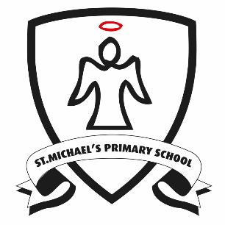 | Reading at Home in Years 3 and 4 How you can help your child…  Learning to read, and then being able to understand a wide range of literary texts, is one of the most important skills your child will master in primary school. For this reason we ask all parents to support their child’s reading at home. In order to support your child’s progress please ensure that they read their independent reading book to an adult at home for ten minutes every night. The adult who has listened must then write a comment in their child’s Reading Record. In this way we are able to track children’s independent reading at home and identify their next steps in learning.
Reading at home encompasses much more than your child’s independent reading book. Parents and other caring adults play an essential part in giving children a love of reading and an interest in books that will give them a strong foundation that we can build upon at school and that will set them up for a lifetime of pleasure from reading. Once children become fluent and independent readers, they may start racing ahead if they have found the books that hook them into reading. It's important at this stage that you continue to read aloud with your child too. When you read aloud, you can share books that offer a challenge in language and content to keep them excited and hungry for more. Choose older classic fiction with literary language as well as contemporary fiction written in a modern style. Choose books with interesting language and rich vocabulary. Short novels that can be serialised and read a chapter or two each night are perfect. Here are some ideas to support your child’s reading:

1. Talk together  All primary age children need opportunities to talk with you about what they are reading or their reading interests. They may also be interested in what you are reading. Talking gives you both a chance to share and recommend. |  | 2. Read together  There is never an age when this is not an enjoyable and useful way to spend ten minutes a day – even your eleven-year-old will still enjoy the sharing opportunity if it’s on offer. It’s a great idea to get your older children to read with younger brothers and sisters too. | 4. Sing together  Why not? Rhythm, rhyme, raps, advertising jingles or the latest top-rated downloadable track can all help the older reader to appreciate and use the patterns of language they hear in both their speech and writing.
3. Revisiting favourites  It’s important for children to know that it’s OK to revisit old favourites and memories – even if this may seem like ‘easy reading’. There’s no mad rush to keep moving on, and we all like the comfort of a favourite book sometimes. Comparing and sharing memories of real life and books will help your child to develop empathy. |  | 5. Making choices  It’s important to still visit book shops, libraries and places where your child can browse and chat with you about their interests. They’ll start to prefer certain authors or series, or types of reading such as comics, magazines or websites, and with your encouragement, they can learn to make choices for themselves too. | 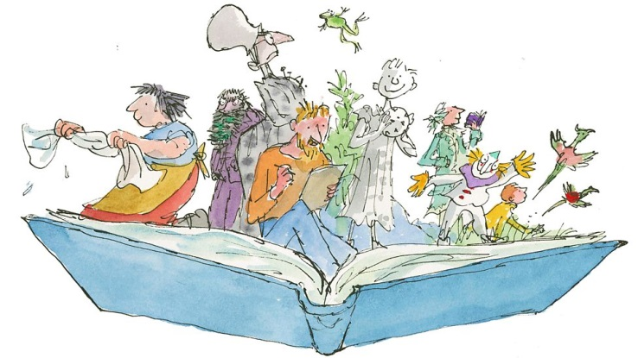

Reading at home in Years 3 and 4 – Questions to ask your child while they are reading
There are two equally important elements of reading that your child will need to develop to become a confident, fluent reader. The first is word recognition - being able to read the words on the page. You can support your child with this by encouraging them to use the strategies they have learnt at school such as using their sounding out and blending words, making links with words they know or using the words around to find meaning. The second element is language comprehension – understanding what the words mean and putting them together to find meaning. It is vital for the development of this skill that you question your child when you are reading. The questions below are appropriate to your child’s year group and can be used to aid your child in securing their language comprehension.
Pupils should be taught to develop positive attitudes to reading and understanding of what they read by:
...listening to and discussing a wide range of fiction, poetry, plays, non-fiction and reference books or textbooks  What happened in the story? Where does the story take place? Who is telling the story? Can you find some words or phrases that tell you about this character? How are you going to use this book to find out about...? | ...reading books that are structured in different ways and reading for a range of purposes  Why is the text arranged in this way? Does the layout and colour of the text have an impact on the reader? How are the beginning and end similar? Is the order of events important? What features make this book similar to (another text)? | ..using dictionaries to check the meaning of words they have read  Can you use alphabetical order to find this word in the dictionary? Which of the meanings given is the correct one for this context? | ...increasing their familiarity with a wide range of books, including fairy stories, myths and legends and re-telling some of these orally  Where and when is this story/text set? How does the writer show this? What effect does the setting have on the story? How did this character respond to (an event)? Can you use a particular action, or tone, to show this?
...identifying themes and conventions in a wide range of books  What is the genre of this story? How do you know? Have you read any other books in this series/by the same author/about this topic?  Do these texts share any common features e.g. language or theme? | ...preparing poems and play scripts to read aloud and to perform, showing understanding through intonation, tone, volume and action  Whose 'voice' is the poem written in? How could you show this in the way you read aloud?  What does this poem make you feel? Can you use intonation to demonstrate this? | ...discussing words and phrases that capture the reader's interest and imagination  What did you enjoy about this story?  What was the most exciting or interesting part? Can you explain why? Which part of the story best describes the setting? Can you identify words in the text which help the author create mood/effect? | ...recognising some different forms of poetry (e.g. free verse, narrative poetry)  Did you hear any repeating patterns or patterns in structure in this poem? Does this poem tell a story? How does the author use the shape of the poem to reflect its meaning? Does the poem follow the pattern of natural speech?
Pupils should be taught to understand what they read, in books they can read independently by:
...checking that the text makes sense, discussing their understanding and  explaining the meaning of words in context  Drawing on what you know about this character already, does his response to (an event) make sense? Can the context of (an unfamiliar word) help you to understand what it means? Why is there a bullet point/exclamation mark/question mark here? What effect does it have? | ...asking questions to improve their understanding of a text  If you could ask the characters in the story a question, who would you choose, and what would you ask? Using the information in this section, can you create questions for your partner? Can you note where the answers are?  Is there a section of the text you don't understand? How could you find out what it means? | ...drawing inferences such as inferring characters' feelings, thoughts and motives  from their actions, and justifying inferences with evidence  Can you choose a character and say what they felt/thought/did in response to events? How do you know? What does... tell you about how the character is feeling? How did this character's actions affect the outcome of the story? | ...predicting what might happen from details stated and implied  Knowing what you do about (a character/an event), what might happen next? Why do you think this? If the story develops in the way you have predicted, how will (a character) respond? Can you find evidence in the text to explain why you think this is? How does the author indicate that (a character) feels excited/worried/scared? Does the author show this directly?
...identifying main ideas drawn from more than one paragraph and summarising  these  Using your understanding of what happened, can you create a timeline of events? What are the main events in this chapter? Can you create a character profile using the key information in each paragraph? Does this help you see how the author has created imagery/tension? | ...identifying how language, structure and presentation contribute to meaning  How are the beginning and end similar? Is the order of events important? Why do you think authors use short sentences? How do the illustrations/choice of font/bold type/italics contribute to the meaning? | Pupils should be taught to retrieve and record information from non-fiction:
What is the text about? What type of text is it? Which subheading could you use instead of this one?
What title could you give this text? When did (an event) first take place? Who were the key people involved?

