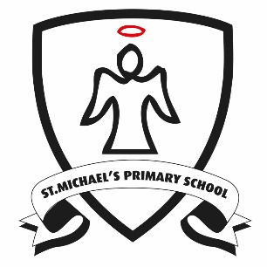 | Reading at Home in Years 5 and 6 How you can help your child…  Learning to read, and then being able to understand a wide range of literary texts, is one of the most important skills your child will master in primary school. For this reason we ask all parents to support their child’s reading at home. In order to support your child’s progress please ensure that they read their independent reading book to an adult at home for ten minutes every night. The adult who has listened must then write a comment in their child’s Reading Record. In this way we are able to track children’s independent reading at home and identify their next steps in learning.
Reading at home encompasses much more than your child’s independent reading book. Parents and other caring adults play an essential part in giving children a love of reading and an interest in books that will give them a strong foundation that we can build upon at school and that will set them up for a lifetime of pleasure from reading. Once children become fluent and independent readers, they may start racing ahead if they have found the books that hook them into reading. It's important at this stage that you continue to read aloud with your child too. When you read aloud, you can share books that offer a challenge in language and content to keep them excited and hungry for more. Choose older classic fiction with literary language as well as contemporary fiction written in a modern style. Choose books with interesting language and rich vocabulary. Short novels that can be serialised and read a chapter or two each night are perfect. Here are some ideas to support your child’s reading:

1. Talk together  All primary age children need opportunities to talk with you about what they are reading or their reading interests. They may also be interested in what you are reading. Talking gives you both a chance to share and recommend. |  | 2. Read together  There is never an age when this is not an enjoyable and useful way to spend ten minutes a day – even your eleven-year-old will still enjoy the sharing opportunity if it’s on offer. It’s a great idea to get your older children to read with younger brothers and sisters too. | 4. Sing together  Why not? Rhythm, rhyme, raps, advertising jingles or the latest top-rated downloadable track can all help the older reader to appreciate and use the patterns of language they hear in both their speech and writing.
3. Revisiting favourites  It’s important for children to know that it’s OK to revisit old favourites and memories – even if this may seem like ‘easy reading’. There’s no mad rush to keep moving on, and we all like the comfort of a favourite book sometimes. Comparing and sharing memories of real life and books will help your child to develop empathy. |  | 5. Making choices  It’s important to still visit book shops, libraries and places where your child can browse and chat with you about their interests. They’ll start to prefer certain authors or series, or types of reading such as comics, magazines or websites, and with your encouragement, they can learn to make choices for themselves too. | 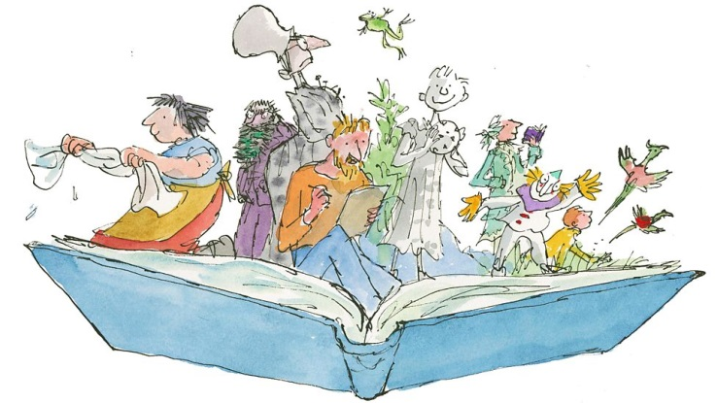

Reading at home in Years 5 and 6 – Questions to ask your child while they are reading
There are two equally important elements of reading that your child will need to develop to become a confident, fluent reader. The first is word recognition - being able to read the words on the page. You can support your child with this by encouraging them to use the strategies they have learnt at school such as using their sounding out and blending words, making links with words they know or using the words around to find meaning. The second element is language comprehension – understanding what the words mean and putting them together to find meaning. It is vital for the development of this skill that you question your child when you are reading. The questions below are appropriate to your child’s year group and can be used to aid your child in securing their language comprehension.
Pupils should be taught to maintain positive attitudes to reading and understanding of what they read by:
...continuing to read and discuss a wide range of fiction, poetry, plays, non-fiction  and reference books or textbooks Would you have chosen to read this book/play/poem yourself? If not, why not? Now you have read it, have you changed your mind? What genre of books does this belong to? How does the front cover show that this book is one in a series? What type of book is this? Is it like any others you have read? | ...reading books that are structured in different ways and reading for a range of  purposes What does this section of text tell you about? When might someone choose to use this book? How is the story/information organised? Why do you think this order/these headings were chosen? Why are we reading this text? Does it inform/excite/engage you? | ..increasing their familiarity with a wide range of books including myths, legends  and traditional stories, modern fiction, fiction from our literary heritage, and books  from other cultures and traditions Have you been in a similar situation to the character in this book? Why do you think this book is regarded as a 'classic'? Where/when is this story/poem set? Does this make a difference to how we read it? Which do you prefer; texts set in historical times or in modern times? Why? | ...recommending books that they have read to their peers, giving reasons for their  choices Who is this book aimed at? Do you think it is successful for this audience? What made you choose this book?  Who would you recommend this book to? Why?
...identifying and discussing themes and conventions in and across a wide range of  writing What is the theme of this book? How does the author create a sense of loss/heroism etc.? Why does the author consistently use the first person in this diary/autobiography? How does the author use metaphor/simile/analogy? Can you make a list of features in this text type? Does the author use these features in the way you would expect? | ...making comparisons within and across books  How do these books deal with the same theme? Do the approaches of the authors differ? What can you say about the viewpoint of the authors? Have you read any other stories which handle time in this way e.g. flashbacks, dreams? | ...learning a wider range of poetry by heart Looking at the way the poem is organised, how does the form of the poem suit the content? Can you find examples of simile/metaphor/alliteration/  personification in this poem? Which words or phrases particularly stick in your mind? | ...preparing poems and plays to read aloud and to perform, showing understanding  through intonation, tone and volume so that the meaning is clear to an audience Some parts of the poem are speech, some are narrative, how can you show the difference between these two features in the way you read aloud/perform?  Can you describe the characters in the play using one word? Could you use this to help you perform their lines effectively?
Pupils should be taught to understand what they read by:
...checking that the book makes sense to them, discussing their understanding and  exploring the meaning of word in context Find an unfamiliar technical word. Consider how it is used in this sentence. What do you think it means?  Does the structure of the book help you to understand the subject? Now that you have read (a section), do you understand why (a character) acted in the way they did? | ...asking questions to improve their understanding  If you could ask the author a question about the text, what would you ask? Can you create a quiz about the text for the class? Is there a section of the text you don't understand? Could you ask a partner for their thoughts? ...summarising the main ideas drawn from more than one paragraph, identifying key details that support the main ideas Can you identify the main idea in each paragraph? What is the most important? Can you describe what happened in 3 sentences? | ...drawing inferences such as inferring characters' feelings, thoughts and motives  from their actions, and justifying inferences with evidence What do you think is going to happen to the main character and how will they feel about this? What makes you think this? Who would you like to meet in the story? Can you give reasons for your choice? Why did (a character) behave in this way? Knowing what you know now, what do you think they were hoping to achieve? | ...predicting what might happen from details stated and implied Using the front cover, can you make a list of details about what you see? Who is on the cover? Where are they? What is in the background? How might these details give us clues about the content of the book? Based on what you know about (a character/event), how do you think the author will develop the story? Can you make a list of details to support your idea, using evidence from the text to say whether they are stated or implied?
...identifying how language, structure and presentation contribute to meaning Can you list words and phrases which show you how the speaker is feeling? Can you find a descriptive phrase and consider the effect it has on the reader? Which words create this effect? What does... mean? Could you use a more emotive word? What about a less emotive word? What effect would this have on the story? Do the events happen in time order? If not, why not? How is the information organised and presented? Why do you think this order/these headings were chosen? | Pupils should be taught to discuss and evaluate how authors use language, including figurative language, considering the impact on the reader: | Pupils should be taught to distinguish between statements of fact and opinion: | Pupils should be taught to retrieve, record and present information from non-fiction:
 | How does the title engage the reader? Give examples of words chosen by the author to describe (a character)? Are they effective? What impression does the author want the reader to have of this character? How do you know? Does the author have a viewpoint on...? How does s/he show this? | How does the title engage the reader? Give examples of words chosen by the author to describe (a character)? Are they effective? What impression does the author want the reader to have of this character? How do you know? Does the author have a viewpoint on...? How does s/he show this? | What specific information do you need to retrieve from this text? Where would you look for information on...?  How could you use the contents/index/glossary to help? Using the information you have, can you plan a day at the museum/zoo/gallery suitable for (a consumer e.g. wheelchair user)? Which is the best location to sit in to watch this play? How do you know?

