Years 5 and 6 Writing Conference Checklist
The Basics
Paragraphs to organise ideas  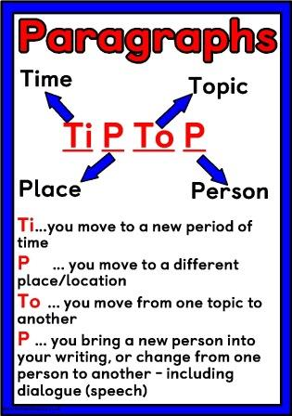 | Capital Letters  Adam is going to Spain on Tuesday.  Full stops  The dog slept.  Question marks  What are you doing?  Exclamation marks  Come here, now!  Ellipsis |  | Commas for lists  He wanted boots, a football, socks and a shirt for Christmas.  Apostrophes for omission and contraction  Dave’s car wasn’t working so he couldn’t take it to Mike’s party.  Correct verb forms  past/present/future
Conjunctions |  | Sentence starters
Co-ordinating  for, and, nor, but, or, yet, so  Subordinating  although, because, now that, until, while  Correlative  Both... and, not only… but also, either… or  Causal  therefore, consequently, as a result, since |  | 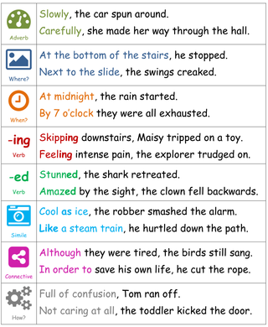
Passive and modal verbs | Use a wide range of clause structures |  | Adverbs, prepositions and expanded noun phrases
Modal:  Can, could, may, might, must, ought, shall, should, may, will, would  Passive voice:  The boy was attached by the snake.  Instead of  The snake attacked the boy. | Vary the structure of your sentences  Jimmy was good at football because his dad taught him lots of tricks.  Because his dad taught him lots of tricks, Jimmy was good at football.  Last night, at the leisure centre, Jimmy was good at football because his dad – a football coach – taught him lots of tricks. |  | Adverbs:  beautifully, enthusiastically, finally, carefully, cautiously, viciously, ferociously  Prepositions:  Down, through, next to, under, over, between, in spite of, as for, along with, in  Prepositional phrases:  Down by the stream…  Under the bridge…  Expanded noun phrase:  Around the corner, the long-bearded old man...

Inverted commas | Commas for clarity | Parenthesis
These enclose direct speech of quotations:  “Come on Fido!” his owner called.  She was quoted in the newspaper: “I love socks!”  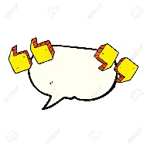 | An introductory phrase or clause:  When Lisa visited the garden, she saw…  Working in pairs (like brackets):  A flower, like a sock, can be stripy.  Direct address:  Let’s eat Grandma vs Let’s eat, Grandma  With adjectives:  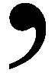  The green, sparkly, blue-eyed fish | Adds extra information to a sentence:  Bart, the oldest child in the Simpsons family, was caught fighting with his classmates – Ralph and Milhouse – at the local skate-park (behind Springfield Elementary).    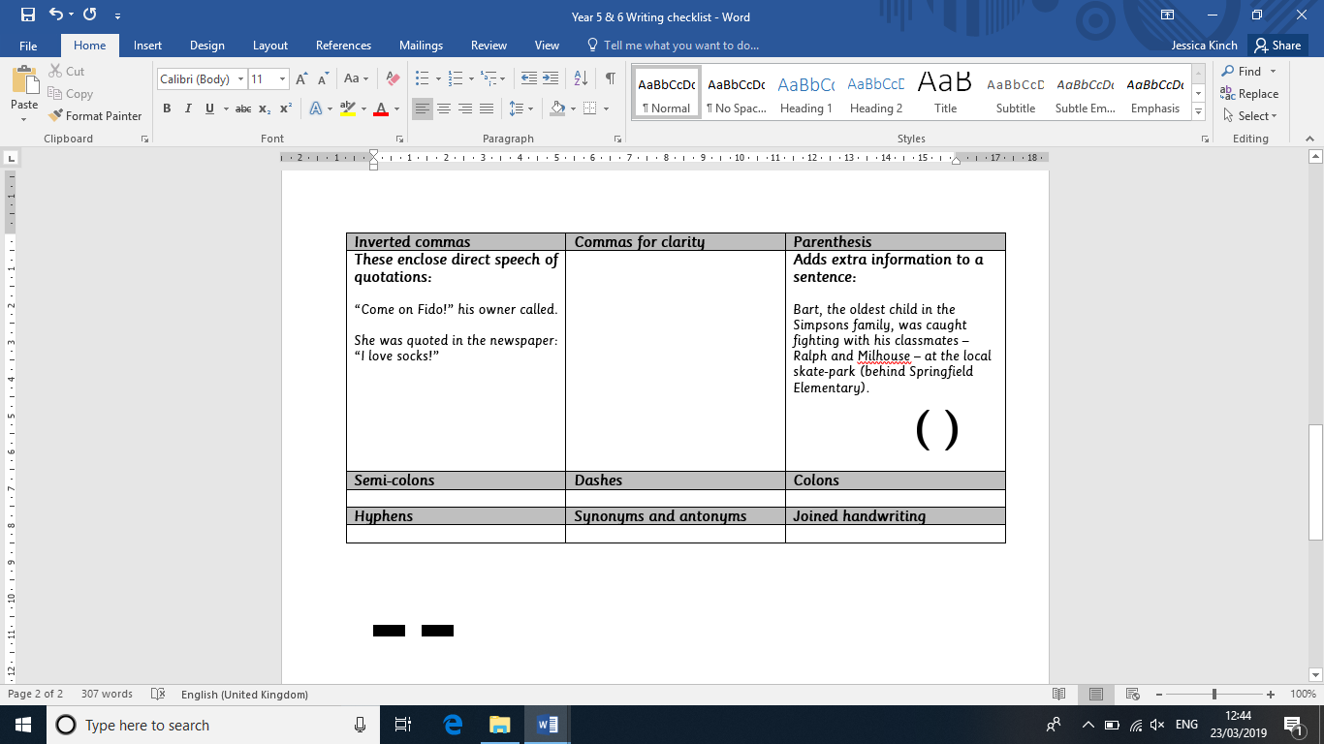
Semi-colons | Dashes | Colons
Connect sections that are closely related:  May was warm; it was pleasant.  It was freezing; he was grateful for his coat  Before certain adverbs:  However, therefore, consequently, nevertheless  June was hot; however, some cities were rainy.  In a long list:  The shopping was packed: free range eggs for mum; tomatoes, beans and cheese for dad; and lots of chocolate for me.  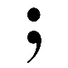 | Extra information at the end of a sentence:  It was a long wait – the longest wait I’ve ever had.  Extra information in the middle of a sentence:  The usually trusty ship – which was already running late – had encountered another problem. | Emphasis:  She thinks about one thing: socks.  Explanations:  They know her secret: she is obsessed with socks.  Lists:  Her socks have the following patterns: stripy, spotty and swirly.  Quotes:  She was quoted in the newspaper: “I love socks!”  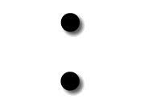
Hyphens | Synonyms and antonyms | Joined handwriting
Used to join two words or to separate parts of words:  The celebrated big-hair society re-formed after twenty-four years for a get-together about their beard- and hair-loss issued. | 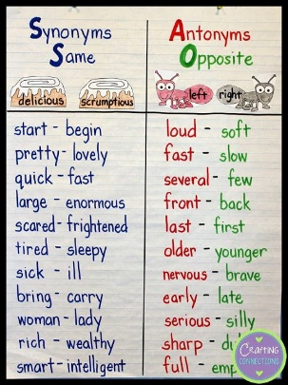 |   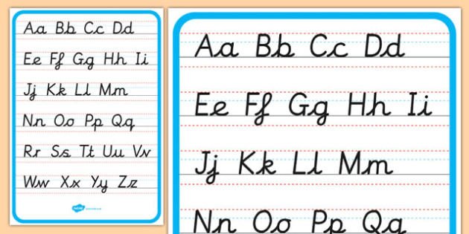  Keep it cursive!

